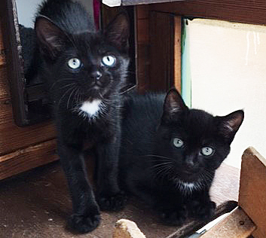
Please read everything we have to say below before completing our pre adoption questionnaire.
FIRSTLY!!!!!!
Before you think of adopting a cat or kitten please consider where you live. Is it close to a busy road or fast traffic? Do you live near supermarket car parks, railway lines, factories or other hazards. Cats are like little children they don't understand what happens if they cross a road, they act entirely on impulse. Sometimes our foster mums will work tirelessly with a cat for many months so they don't want them to end up under the wheels of a car. We will not rehome any of our cats where we think they will be at risk. We cannot avoid cars but we have to find the best and safest homes for our cats and kittens

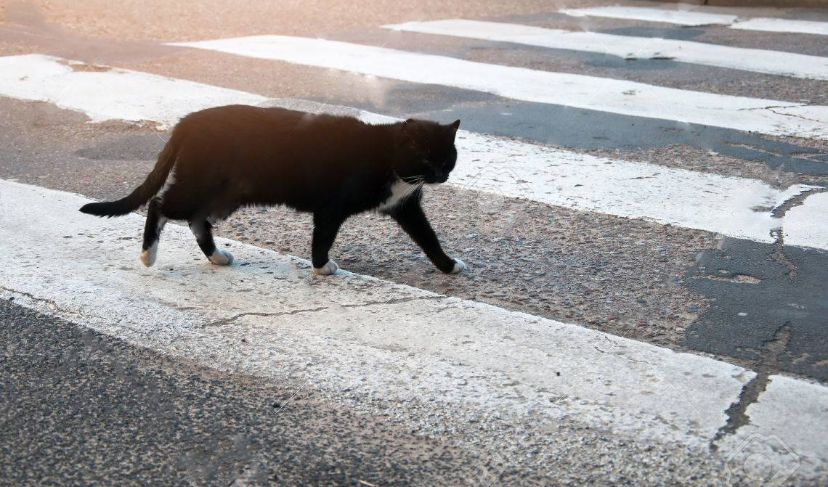

Points to consider before you apply for a cat:
- Some (but not all) of our cats are traumatised, insecure and sometimes they have also been physically abused. It will be your responsibility to rehabilitate these cats which will require your patience, understand and full cooperation.
- They often need a lot of time spent on them so generally they are not suitable to be left for long periods of time. Kittens in particular benefit from not being left for long periods so please consider this before applying. Please make sure you have time to spend with your cat or kitten for play and socialisation.
- We are looking for homes for all our cats where they live as part of the family. Please consider the age of the cat/kitten you want to adopt against your own age before applying. Some cats can live into their twenties so you will have to make provision for them in your old age should you not be able to care for them. Whilst we understand life holds no guarantees we try to give every cat the best possible chance of a home for the rest of it’s life.
- We will allow cats to be adopted to homes with children of all ages as long as the cat is suitable for that environment. We will discuss your circumstances and try to determine if the cat you’re interested in will be suitable for your home/family/lifestyle/other pets.
- Your garden must be safe, away from traffic and passing cars and not close to any hazards ie factories, shopping areas, car parks.
- We are looking for wonderful, responsible, forever homes. That means asking questions and trying to marry up the correct pet with the prospective family. We are not judgmental but we have a very large responsibility to make sure we do what’s right for you and especially for our charges.

Adoption Procedure
Once you have completed an application form you will be automatically added to our database.
If you have applied for a specific cat we will discuss some of your answers in order to ascertain if we think the cat you are applying for is a suitable match for your lifestyle, or if we have any cats relative to your application. If we do not feel the cat is a match we will keep you on our list or we may suggest a different cat to you. If we feel your application is a match we will contact you, we will be able to tell you a lot more about the cat and answer any questions you may have.
Once it is agreed to go ahead with the application, and you have decided on a cat that you would like to adopt after meeting him or her a home check will be arranged.
In some circumstances you may be asked to provide references, i.e. if you live in rented accommodation we will need to see proof that your landlord allows you to have a cat.
All members of the family and any pets who will be living with the cat you want to adopt must come to meet the new cat or be available to meet at the home check stage. We do not we do not let third parties collect for you or deliver cats to their new homes unless they are verified through u
If you are applying for a kitten you will also be asked to sign a contract to say you will neuter your kitten at a certain age and get your vet to sign a proof of neutering certificate once spayed or neutered.
Adult cats are neutered, micro chipped, had at least their first inoculation, flea treatment and wormed. All kittens are flead, wormed, micro chipped, had at least their first inoculation. If your kitten has not been spayed/neutered a declaration will be signed at time of adoption requiring a new owner to spay or neuter. Each cat is covered by Agria Insurance for 5 weeks, the first week is accident only and the next 4 weeks are full health insurance.

Adoption Fee
The adoption fee for our cats is at £90 and we would appreciate it if you could donate more than this to help other rescue cats and kittens in our care. We would also love it if you could sponsor our Waterside Cattery - All sponsors receive the following:
- Exclusive access to our sponsor-only Facebook page, which is always updated with the current residents you’re helping.
- An invitation to visit your sponsored pen for a ‘Cat Cafe’ with the residents.
- A welcome pack including a certificate of sponsorship and a cat notecard
- Your name on the ‘wall of fame’ in the cattery
- An extra handmade surprise from us, whilst stocks last
Your donation helps all the cats in our care. We want sponsorship to be accessible to everyone, so a year’s sponsorship starts from just £15, but if you can give more we’d really appreciate it.
It makes an ideal gift for cat lovers too!
The adoption fee is considered a donation to Shropshire Street Cats and thereby is NON REFUNDABLE.

Where it goes:
- We spend a huge amount each year on vet treatments and supplies. All our adult cats are spayed (unless there is a medical reason for not doing so), have had at least the first inoculation, micro chipped and wormed.
- If needed, we have x-rays, lab tests, specialist procedures and operations carried out and often numerous additional medicines and treatments are needed for both adult cats and kittens. There is often specialist food to buy and the upkeep and heating of our pens.
- The adoption fee for kittens (although they are not spayed/neutered) goes towards the worming and inoculations and helps with the extra costs of so many specialist operations that other cats at Shropshire Street Cats have to endure to give them a chance of a normal life.
- Volunteers spend a huge amount of time and effort fostering, fundraising, transporting and carrying out admin, all done voluntarily.
We hope this will help everyone understand the cost of running this rescue and also let people see where their donations are spent. We are a not for profit rescue and a registered charity.
If you are happy to proceed please fill in the questionnaire below and return it to us via email at: shropshirestreetcats@outlook.com

Cat Adoption Questionnaire

Date ______________________
Name _______________________________
Surname ______________________________
Address ____________________________________________________
Postcode ____________________________________________________
Telephone __________________ Mobile _________________
Email ___________________

Are you interested in a kitten/cat

Your family
Who are you adopting this pet for?
Myself Family Other
Who will be the primary caregiver for this pet
Me My partner My child Other
Number of children at home?
______________________
Please list their ages
______________________
Pet allergies in the family?
Your home lifestyle
What type of home do you live in?
Detached House Bungalow Rural Property Flat Other
Is your house situated near any busy roads or fast moving traffic?
Do you have a back garden?
What is behind your garden?
Other houses the gardens of other houses a field

Do you?
Own Rent Council accommodation
Do you have your landlord’s permission to have pets?
Yes No
How long have you lived at your present address?
____________________________
Are you considering moving home in the near future (if so many landlords will not accept pets)
__________________________________
If you had to move what would happen to your pets? Could you guarantee that they would move with you?
__________________________________
How many people live in your home?
____________________________
Where will your pet stay during the day?
Mainly indoors
Indoor enclosure
Free access (cat flap)
Free roaming
Fenced garden if so fencing material and height?
Where will your pet sleep at night?
Indoors Outdoors Enclosure
On average how many hours will you spend with your pet
Weekdays ____________ Weekends _______________
On average how many hours will your pet be alone on
Weekdays ____________ Weekends _______________

Your pets
Are there other pets CURRENTLY in your household?

Type(dog or cat) | Breed | Age | Sex | Neutered | How long owned

Have you owned other pets previously?
Type(dog or cat) | Breed | Age | Sex | Neutered | How long owned

Would you consider adopting an animal with special behavioural or medical needs?

Yes No Unsure
Are you prepared for the medical costs entailed in adopting a cat of kitten
Yes No
Are you prepared to vaccinate your cat or kitten on an annual basis
Yes No
Is your present pet fully vaccinated up to date?
Yes No
Would you consider taking out health insurance to cover your cat or kitten
Yes No

Can you please tell us where you heard about adoptions from SHROPSHIRE STREET CATS?

Facebook Website Adopt a Pet Website Newspaper Family or friend Other

This selection to be completed by SHROPSHIRE STREET CATS Adoption staff

Adoption team member name:
Date:

Adopted animal of interest Adopted another animal Did not adopt

Notes:

Topics required to be covered before finalising adoption

GENERAL

Landlord requirement
Microchip
Housing
Fencing/containment
Financial considerations

MEDICAL

Dietary
Vaccination
Flea and worm programme
Common health concerns (cat flu/FIV/HIV/giardia)
Insurance cover explained

BEHAVIOURAL
Settling into new home
Introduction to children and pets
House training
Enrichment
Exercise

SPECIAL ADOPTION ANIMAL
Behavioural
Medical
Relevant handouts provided

I confirm that I have provided SHROPSHIRE STREET CATS with true and accurate information in my adoption questionnaire I agree that the Adoption Team Member has explained the above information to me and I have understood the conditions relation to the adoption.

Adopter name ____________________________ Adopter signature ___________________

www.shropshirestreetcats.co.uk
email: shropshirestreetcats@outlook.com
Tele: 07443507526

